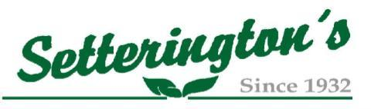
Custom Application Operator
Setterington’s Fertilizer Service Ltd. is a leading provider of agricultural crop inputs and services in the Essex & Chatham-Kent area. Our business provides fertilizer, crop protection products, as well as services such as custom spraying and nutrient application. With multiple locations to serve our great customers! We currently have an opportunity for you to join our team as a Custom Application Operator at our Cottam and or Blytheswood location.
This Full-time position offers a competitive wage, benefits, and pension plan to the successful candidate.

Key Responsibilities:
- Operate various heavy equipment-custom application machinery, airflo, spinner truck, to apply custom application products;
- Apply custom spraying crop protection products (if you do not have an exterminator license, we would help obtain one); experience would be an asset;
- General maintenance of equipment;
- Yard duties could include but not be limited to unloading/loading trucks, pumping 28%, aiding in chemical warehouse, making deliveries.
Requirements:
- Valid Driver’s License, DZ license is an asset;
- Farm, equipment, or mechanical background an asset;
- Customer Service oriented and dependable;
- Willing to work extended hours and weekends during peak times of year.

If you are interested in joining our team, please forward resumes to:
Setterington’s Fertilizer
Attn: Nikki Taylor
601 County Road 14
Leamington, ON N8H 3V8
519-326-9093
nikkitaylor@setteringtons.com

